

|  |  |
| --- | --- |
| **ASSIGNMENT** | |
| **Course Code** | 19CSC312A |
| **Course Name** | Artificial Intelligence |
| **Programme** | B. Tech. |
| **Department** | Computer Science and Engineering |
| **Faculty** | FET |

|  |  |
| --- | --- |
| **Name of the Student** | Bharath Kumar B ; Charith Kumar S ;  Deepak R ; |
| **Reg. No** | 18ETCS002032 ; 18ETCS002039 ; 18ETCS0020041 |
| **Semester/Year** | 6th /2018 |
| **Course Leader/s** | Dr. Subarna Chatterjee |

|  |  |  |  |  |  |  |  |  |
| --- | --- | --- | --- | --- | --- | --- | --- | --- |
| **Declaration Sheet** | | | | | | | | |
| Student Name | Bharath Kumar B ;Charith Kumar S ; Deepak R | | | | | | | |
| Reg. No | 18ETCS002032 ; 18ETCS002039 ; 18ETCS002041 | | | | | | | |
| Programme | B. Tech. | | | | | Semester/Year | 6th /2018 | |
| Course Code | 19CSC312A | | | | | | | |
| Course Title | Artificial Intelligence | | | | | | | |
| Course Date |  | | to | |  | | | |
| Course Leader | Dr. Subarna Chatterjee | | | | | | | |
| **Declaration**  The assignment submitted herewith is a result of my own investigations and that I have conformed to the guidelines against plagiarism as laid out in the Student Handbook. All sections of the text and results, which have been obtained from other sources, are fully referenced. I understand that cheating and plagiarism constitute a breach of University regulations and will be dealt with accordingly. | | | | | | | | |
| Signature of the Student | |  | | | | | Date |  |
| Submission date stamp  (by Examination & Assessment Section) | |  | | | | | | |
| Signature of the Course Leader and date | | | | Signature of the Reviewer and date | | | | |
|  | | | |  | | | | |

|  |  |  |  |
| --- | --- | --- | --- |
| **Faculty of Engineering and Technology** | | | |
| Ramaiah University of Applied Sciences | | | |
| Department | Computer Science and Engineering | Programme | B. Tech. |
| Semester/Batch | 6th/2018 | | |
| Course Code | 19CSC312A | Course Title | Artificial Intelligence |
| Course Leader(s) | Dr. Subarna Chatterjee, Gp. Capt. Rath and Santoshi Kumari | | |

|  |  |  |  |  |  |  |  |  |
| --- | --- | --- | --- | --- | --- | --- | --- | --- |
| Assignment-1 | | | | | | | | |
| Register No | | | 18ETCS002032 18ETCS002039 18ETCS002041 | Name of Student | | Bharath Kumar B Charith Kumar S Deepak R | | |
| Question | Marking Scheme | | | | Marks | | | |
| Max Marks | | First Examiner Marks | Moderator |
| 1 |  | | | | | | | |
| 1 | Executive summary | | | **03** | |  |  |
| 2 | Background and Objectives | | | **04** | |  |  |
| 3 | Comparative analysis of state-of-the-art methods | | | **10** | |  |  |
| 4 | Conclusion and Recommendations | | | **03** | |  |  |
| 5 | Presentation | | | **05** | |  |  |
| **Max Marks** | | | | **25** | |  |  |
| **Total Assignment Marks** | | | | | 25 | |  |  |

|  |  |  |  |  |
| --- | --- | --- | --- | --- |
| **Course Marks Tabulation** | | | | |
| **Question** | **First Examiner** | **Remarks** | **Moderator** | **Remarks** |
| **1** |  |  |  |  |
| **Marks (Max 25 )** |  |  |  |  |
| **Signature of First Examiner Signature of Moderator** | | | | |

**Please note:**

1. Documental evidence for all the components/parts of the assessment such as the reports, photographs, laboratory exam / tool tests are required to be attached to the assignment report in a proper order.
2. The First Examiner is required to mark the comments in RED ink and the Second Examiner’s comments should be in GREEN ink.
3. The marks for all the questions of the assignment have to be written only in the **Component – CET B: Assignment** table.
4. If the variation between the marks awarded by the first examiner and the second examiner lies within +/- 3 marks, then the marks allotted by the first examiner is considered to be final. If the variation is more than +/- 3 marks then both the examiners should resolve the issue in consultation with the Chairman BoE.

Contents

**Declaration Sheet** 2

**Question No.: 1** 6

1. Executive Summary/Abstract of the Topic emphasizing the application area, challenges and the role of AI to find solutions 6

2. Background and Objectives 8

3. Comparative analysis of state of art methods 11

4. Conclusion and Recommendation 16

5. Presentation 16

**References** 17

**Acronym used and their Abbreviation**

AI – Artificial Intelligence; ML-Machine Learning; DL-Deep Learning; WSI- whole slide digital imaging;

# **Question No.: 1**

**Solution to Question No. 1:**

## Executive Summary/Abstract of the Topic emphasizing the application area, challenges and the role of AI to find solutions

**Abstract**

With recent progress in machine learning and computing infrastructure, Artificial Intelligence aims to bring drastic change in health care, by increasing availability of healthcare data and a greater progress of analytics techniques. In this case study describes techniques for representing medical performance instructions and facilitating their beginning into the clinical routine. AI involves the use of deep learning, Natural language processing, Context aware processing and Intelligent Robots which helps AI in providing robust solutions to the healthcare. Artificial Intelligence is a tool for health care offers to improve reduced cost, clinical team outcomes and early detection of disease and its diagnosis, treatment and also the outcome of disease prediction and prognosis evolution and in biomedicine research. Artificial Intelligence also used as living assistance in home. Areas that use Artificial Intelligence tools include in diseases like cancer, neurology and cardiology. Artificial Intelligence also used as living assistance in home. Artificial Intelligence also used as virtual assistant for health care as a robot. In healthcare AI is also used in image diagnosis. AI also has healthcare application in automated imaging to intelligent drug design and in artificial neural networks. AI by the method data mining can predict the diseases prior to their occurrence. AI in maintaining ELECTRONIC HEALTH RECORDS(EHR). Here we do a case study on current status of Artificial Intelligence in above applications in health care. Also the challenges Ai facing in those area and compare the state-of-the-art methods used in them and concludes about the role of AI in those areas and performance of AI in those areas. The main aim of this case study is to keep track of new scientific accomplishments and existing methods in health care by using AI techniques, to understand the availability of technologies, to appreciate the tremendous potential of AI in healthcare and it provides researchers in related fields with inspiration.

**Challenges in health care and the role of AI to find solutions**

1. One of the biggest challenges in drug development is conducting successful clinical trials. As it stands now, it can take up to 15 years to bring a new and potentially life saving drug to market, according to a report  in Pharmacological Sciences. It can also cost between $1 and $2 billion. Around half of that time is spent in clinical trials, many of which fail.

**AI’s solution:-** Using AI technology, , researchers can identify the right patients to participate in the experiments. Further, they can monitor their medical responses more efficiently and accurately saving time and money along the way.

1. Clinicians would manually write down or type observations and patient information. Often, they would do it after the patient visit, inviting human error.

**AI’s solution:-** Interactions with patients, clinical diagnoses, and potential treatments can be augmented and documented more accurately and in near real-time by AI’s deep learning-backed [speech recognition technology](https://www.nuance.com/healthcare/artificial-intelligence.html).

1. Treatment of different cancers using immunotherapy giving less success rates became a major challenge.

**AI’s solution:-**

Machine learning algorithms and their ability to synthesize highly complex datasets be able to illuminate new options for targeting therapies to an individual’s unique genetic makeup.

1. Disease detection in early stage or before their occurrence.

**AI’s Solution:-**Data mining in AI helps for early detection of diseases by using clinical and diagnosis data of patient data or by mining the medical records in larger data bases. By proper analysis of data using ML tools, healthcare sector can address plethora of diseases.

1. A patient with multiple symptoms that can correlate with various conditions by both genetic and physical characteristics, which can delay a diagnosis and treatment.

**AI’s solution:-**Supervised learning of machine learning uses the physical traits of the patient, backed with a database of information, to provide a more targeted outcome and treatment.

1. Predicting disease outcome and prognosis evolution of heart stroke

**AI’s solution:-**By using machine learning predicting disease outcome by analyzing physiological parameters during 48hours after stroke using logistic regression.

1. Proper machines for physically disabled people and old people

**AI’s solution:-** AI applications using corresponding smart robotic systems are paving the way for improvements in life quality by using intelligent solution models based on wireless sensor networks, data mining trains machines based on facial recognition by image processing.

1. Patients home assistant for health tips and medication and analyzing patients medical history

**AI’s solution:-Virtual assistant** sing Machine Learning and Natural Language Processing techniques, it becomes extremely convenient to navigate through medical databases in order to get the desired information. In addition, these assistants are able to deliver personalized notes to a patient by analyzing their medical information and history.

1. Proper detection of region in an organ or tissue which has suffered damage through injury or disease, such as a wound, ulcer, abscess, or tumour is a major challenge in radiology

**AI’s solution:-** Deep Learning can help radiologists in multiple ways. Application of deep learning like autoencoders can help improve the image quality by ‘repairing’ the pixels.

1. Treating Rare and new diseases and detecting it

**AI’s solution:-** [BERG](https://www.berghealth.com/) is a clinical-stage, AI-based biotech platform that maps diseases to accelerate the discovery and development of breakthrough medicines.By using used AI to find links between chemicals in the human body that were previously unknown to detect disease.

1. Presence of Highest lung cancer rates in the world.

**Solution:** Use AI and deep learning to diagnose cancer by pairing a computerized tomography (CT) scan with AI

## Background and Objectives

Artificial Intelligence is an umbrella term under which it is made of vast variety of different sub concepts in order to develop a human like intelligent system. There are two subsets of Artificial Intelligence: Machine Learning and Deep Learning. Data Science is a field where all these technologies and concepts (AI, ML and DL) are used to make a data driven decision and solve a real-world use case problem. Therefore, Data Science is not the superset of AI, ML and DL but overlaps all these concepts to make a data driven decision.

**AI background in healthcare:-**

AI in medicine even goes back to 1964 with Eliza, the very first chatbot, which was a conversational tool that recreated the conversation between a psychotherapist and a patient. That also was the early days of applying artificial intelligence and rules-based systems on the interaction between patients and their caregivers. Clinical informatics databases and medical record systems were also first developed during this time by AI. A “backward chaining” AI system, MYCIN, was developed in the early 1970s. Based on patient information input by physicians and a knowledge base of about 600 rules, MYCIN could provide a list of potential bacterial pathogens and then recommend antibiotic treatment options adjusted appropriately for a patient’s body weight. MYCIN.11 INTERNIST-1 was later developed using the same framework as EMYCIN and a larger medical knowledge base to assist the primary care physician in diagnosis.

In 1986, DXplain, a decision support system of machine learning(ML) uses inputted symptoms to generate a differential diagnosis. It also serves as an electronic medical textbook, providing detailed descriptions of diseases and additional references. DXplain was able to provide information on over 2400 diseases. By the late 1990s, interest in Machine Learning was renewed, in the medical world by this.

A **convolutional neural network (CNN**) is a type of DL algorithm applied to image processing that simulates the behavior of interconnected neurons of the human brain. A CNN is made up of several layers that analyze an input image to recognize patterns and create specific filters. The final outcome is produced by the combination of all features by the fully connected layers. Several CNN algorithms are now available, including Le-NET, AlexNet, VGG, GoogLeNet, and ResNe.

**AI in cardiology:-**Arterys became the first U.S. Food and Drug Administration–approved clinical cloud-based Deep Learning(DL) application in health care . The first Arterys product, CardioAI, was able to analyze cardiac magnetic resonance images in a matter of seconds, providing information such as cardiac ejection fraction. This application has since expanded to include liver and lung imaging, chest and musculoskeletal x-ray images, and noncontrast head CT images.

The application of AI in gastroenterology has expanded greatly over the last decade. Computer-assisted diagnosis can be applied to colonoscopy to improve the detection of and differentiation between benign versus malignant colon polyps. By using the EUS platform, AI has been used to help differentiate chronic pancreatitis from pancreatic cancer, a common clinical challenge. History of AI in diagnosis and surgery:-

Computer vision has mainly been based on statistical signal processing but is now shifting more toward application of artificial neural networks as the choice for learning method. Here, DL is used to engineer computer vision algorithms for classifying images of lesions in skin and other tissues. Video data is estimated to contain 25 times the amount of data from high-resolution diagnostic images such as CT and could thus provide a higher data value based on resolution over time.

**AI-assisted endoscopy** is an evolving field with a promising future. Initial applications included computer-aided diagnosis (CAD) for the detection, differentiation, and characterization of neoplastic and non-neoplastic colon polyps. A recent randomized controlled trial of 1058 patients demonstrated a significant increase in adenoma detection rates with the use of CAD compared with standard colonoscopy.

**Objectives**

1. The main objective of using artificial intelligence in the field of healthcare is to determine the success rate of prevention and cure procedures for a given disorder, disease or any other medical condition.
2. AI aims at developing an algorithm based on the outcomes of treatments, diagnosis patterns, development of personalized medicine, drug development and various other medical procedures.
3. AI systems wants to take responsibility for routine and less risky diagnostic and treatment processes. The aim of AI here is not to replace human clinicians but enable a streamlined high-quality healthcare delivery process.
4. AI systems aims to get more trained and consequently intelligent; it is foreseeable that these agents replace some of, but not all, the human elements of clinical care.
5. Robotic assistants have already been employed to conduct surgeries, deliver medication and monitor hospital patients but in future AI’s objective is to for their use is in elderly care and with advances in AI and robotics, the employment of robotic assistants in elderly care is the main objective.
6. the imaginable development of a hybrid human-artificial intelligence health worker that can revolutionize healthcare delivery.
7. development of a hybrid human-artificial intelligence health worker that can revolutionize healthcare delivery.
8. AI’s objective is to improve next generation radiology tools that will no longer rely on tissue samples. It will be able to analyses 3D scans 1000 times faster than human minds.
9. Integrating AI into healthcare ecosystem allows for a multitude of benefits, including automating tasks and analyzing big patient data sets to deliver better healthcare faster, and at a lower cost.
10. To diagnose heart disease through cardiac image and create a remedy through automated editable ventricle segmentations by AI.
11. For chronically ill patients, disease management and care plans can be approached in a comprehensive manner by AI.
12. By using machine learning with neuro science AI’s objective is to build an algorithm with neural network that can detect medical conditions faster

## Comparative analysis of state of art methods

Current research is been going on in the field of Dermatology, Radiology, Screening, Psychiatry, Primary care, Disease diagnosis, Telemedicine, Electronic health records, Drug Interactions and finally Creation of new drugs and vaccinations.

Any fundamental machine learning problem is solved by statistical analysis and algorithm design. The statistical analysis tells us the principles of the mathematical models that we establish from the observation data whereas the algorithm design defines the conditions on which implementation of data models and data sets rely. A newly discovered challenge to ML is the Rashomon effect, which means that data are possibly generated from a mixture of heterogeneous sources. A simple classification standard can shed light on emerging forms of ML.

State-of-the-art (SoTA) is a step to demonstrate the novelty of the research results.

**AI role in identifying Metastatic Breast Cancer**

Concept and methods used: Deep Learning, Computer Vision, Pattern Recognition, Image Pre-processing

Dataset and Evaluation Metris followed: **Camelyon16 dataset** consists of a total of 400 whole slide images (WSIs) split into 270 for training and 130 for testing. Slide-based Evaluation (based on performance at discriminating between slides containing metastasis and normal slides)and Lesion-based Evaluation (based on probability and a corresponding (x, y) location for each predicted cancer lesion within the WSI. Measured performance as the average sensitivity for detecting all true cancer lesions in a WSI across 6 false positive rates) are used to evaluate results.

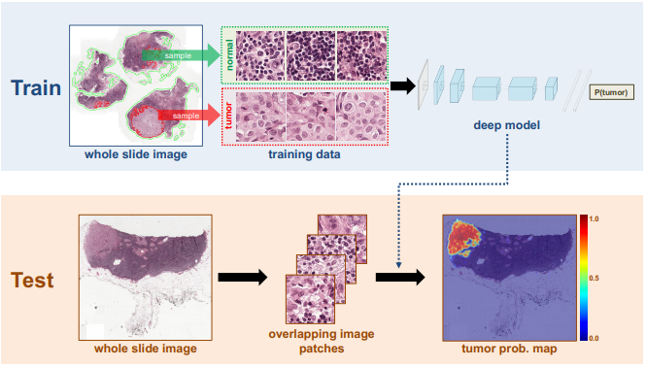

Figure

*Figure 1* represents the framework and steps used for cancer metastases detection.

Here the patch-based classification stage takes as input whole slide images and the ground truth image annotation, indicating the locations of regions of each WSI containing metastatic cancer. The extracts of millions of small positive and negative patches from the set of training WSIs. If the small patch is located in a tumor region, it is a tumor / positive patch and labeled with 1, otherwise, it is a normal / negative patch and labeled with 0. Following selection of positive and negative training examples, we train a supervised classification model to discriminate between these two classes of patches, and we embed all the prediction results into a heatmap image. In the heatmap-based post-processing stage, we use the tumor probability heatmap to compute the slide-based evaluation and lesion-based evaluation scores for each WSI.

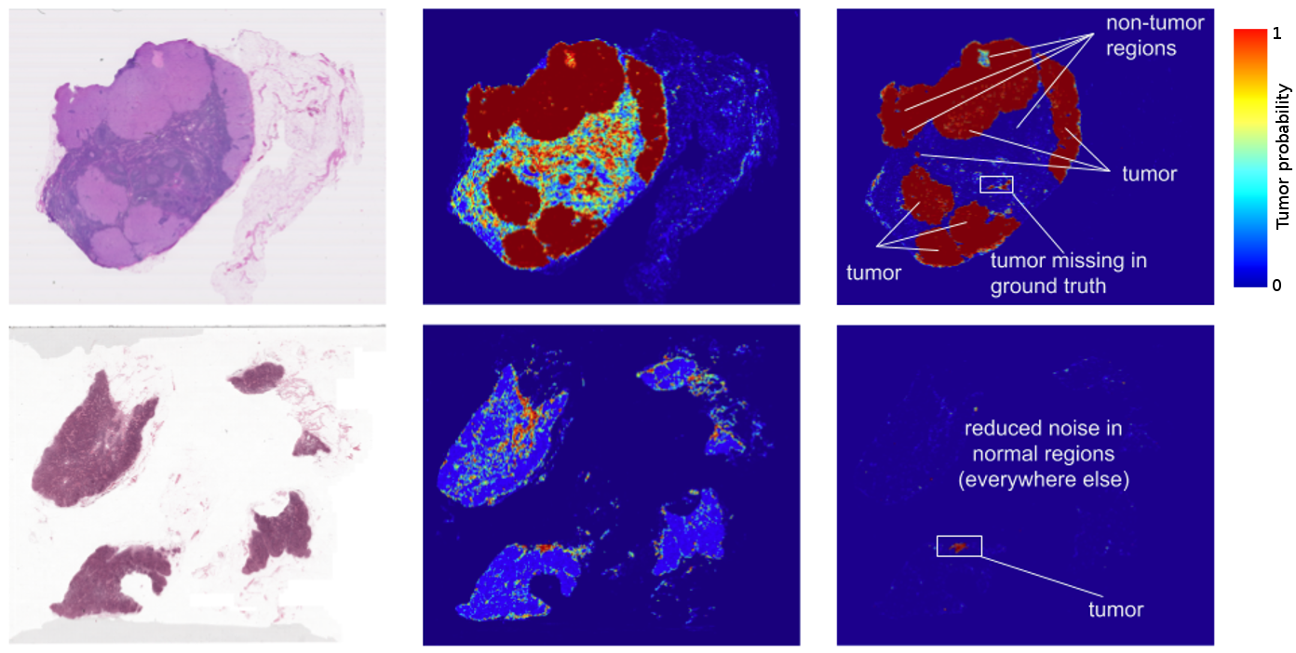

Figure

*Figure 1* represents the Deep Learning technique for Identifying Metastatic Breast Cancer, the image shows the comparative analysis of detecting the probability of detecting the cancer.

Here the challenge is to evaluate computational systems for the automated detection of metastatic breast cancer in whole slide images of sentinel lymph node biopsies. Obtaining an area under the receiver operating curve (AUC) of 0.925 for the task of whole slide image classification and a score of 0.7051 for the tumor localization task. A pathologist independently reviewed the same images, obtaining a whole slide image classification AUC of 0.966 and a tumor localization score of 0.733. Combining deep learning system's predictions with the human pathologist's diagnoses increased the pathologist's AUC to 0.995, representing an approximately 85 percent reduction in human error rate. These results demonstrate the power of using deep learning to produce significant improvements in the accuracy of pathological diagnoses.

**AI role in Medical Diagnostic Systems**

Diagnosis has been defined as the method of identifying a disease from its signs and symptoms to conclude its pathology. Diagnosis can also be defined as the method of figuring out which disease is based on an individual’s symptoms and signs. The data gathered from medical history physical examination of the individual having medical pathology constitutes the knowledge required for diagnosis. Often, at least one diagnostic procedure, such as medical tests, is done during this procedure. To form an honest diagnosis, a medical doctor will perform a process that involves several steps, allowing them to collect the maximum amount of information as possible. Diagnosis of diseases is the most challenging process at the same time, a very pivotal phenomenon for a medical care professional as before reaching the conclusion.

Classification of diseases depending upon various parameters is a complex task for human experts but AI would help to detect and handle such kinds of cases. Currently, various AI techniques have been used in the field of medicine to accurately diagnosis sicknesses. AI is an integral part of computer science by which computers become more intelligent. The vital need for any intelligent system is learning. There are various techniques in AI that are based on Learning like deep learning, machine learning, etc. Some specific AI methods that are significant in the medical field named as a Rule-based intelligent system, provides a set of if-then rules in healthcare, which act as a decision support system. Gradually, intelligent systems are being replaced in the medical field by AI-based automatic techniques where human intervention is very less. Modern AI algorithms already help doctors in arranging a comprehensive approach to disease management. Moreover, they are often used to improve surgical robots that execute highly complex operations.

Steps for the diagnosis process are: The Medical History -> Physical examination ->Performing Diagnosis tests -> Drawing conclusions

Fuzzy logic process for Disease Diagnosis: Fuzzy logic provides dynamic methods that deal with difficult problems. Fuzzy logic is assumed to be a solid tool for decision-making systems, such as expert systems or Pattern classification systems. These frameworks give an outcome depending on the knowledgebase incorporated within or from specialists or experts in the field. Various clinical diagnoses systems created depend on the fuzzy set model and applied in the medical field. ‘Fuzzy’ means ambiguous. Ehen we are uncertain about whether the state is valid or invalid, wherein fuzzy logic provides reasoning for such conditions as depicted and moreover it is a rule based method. Fuzzy RuleBased System (FRBS) is a frequently used technique in healthcare that drives from Fuzzy Inference Systems (FIS). FRBS applies IF-THEN rules for information portrayal. Most diagnosis processes have been performed based on the probability of medical findings.

Fuzzy logic steps for disease diagnosis: • Fuzzifier: The Fuzzification process is done by a Fuzzifier. It is a process of changing a crisp input value to the fuzzy set. Hence Fuzzifier is used as a mapping from observing input to fuzzy value. • Inference engine: After completing the fuzzification process, fuzzy value processed by the inference engine using a set of rules act as a collection of rules to the knowledge base. • Knowledgebase: This is the main component of the fuzzy logic system. The overall fuzzy system depends on the knowledge base. Basically, it consists of rules, structured and unstructured data also named the database. • Defuzzifier: The process of converting the output from the inference engine into crisp logic. Fuzzy value is an input to the defuzzification that maps fuzzy value to crisp value.

There are also other methods in AI like machine learning and deep learning methods other than fuzzy logic to diagnosis a disease.

The steps followed in the machine learning process to diagnosis disease is : 1) Collect test data with patient details. 2) The feature extraction process picks attributes which are useful for disease prediction. 3) Afterward, the selection of attributes, then select and process the dataset. 4) Various classifications methods as mentioned in the diagram can be applied to preprocess dataset to evaluate the accuracy of prediction of disease. 5) The performance of different classifiers compared with each other in order to select the best classifier with the highest accuracy.

In Machine learning, all the features extracted by a domain specialist to minimize the complications of data and to develop patterns in such a way that would easily visible to ML algorithms. However, deep learning based technique can extract features manually without human intervention, the only condition is to make precise decisions in which the testing data could be accurate. This technique eliminates the requirement of a domain expert for feature extraction. And this is the main difference between the machine learning and deep learning methods in diagnosing a disease.

Following describes the comparative analysis of the deep learning method, machine learning method and fuzzy logic method in AI to diagnosis a disease.

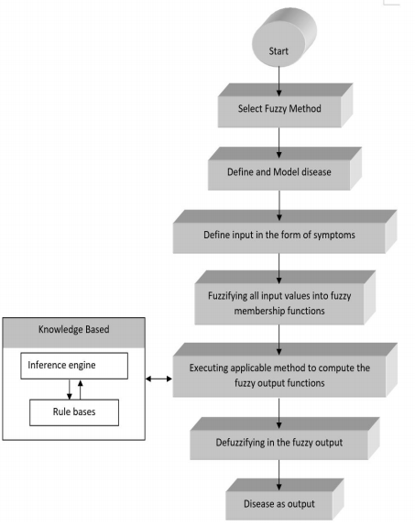

Figure

*Figure 3* represents the Fuzzy logic method or procedure in AI to diagnosis a disease.

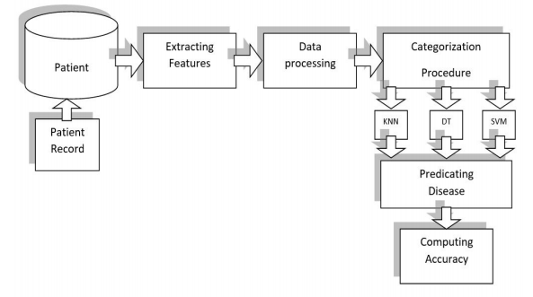

Figure

*Figure 4* represents the Machine learning method or procedure in AI to diagnosis a disease.

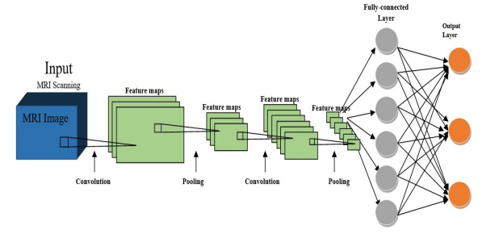

Figure

*Figure 5* represents the Machine learning method or procedure in AI to diagnosis a disease.

## Conclusion and Recommendation

Various specialties in medicine have shown an increase in research regarding AI. As the novel coronavirus ravages through the globe, the United States is alone estimated to invest more than $2 billion in AI related healthcare research over the next 5 years, more than 4 times the amount spent in 2019 ($463 million). The GPU in the cloud movement has quickly accelerated AI into one of the today’s biggest enterprise technology. Besides GPU computing power FPGA’s and ASIC are emerging with the higher computational standards.

Healthcare AI startups are quickly growing. More than 300 startups have emerged since 2016, and a record 77 first equity deals were made just last year.

AI can undoubtedly bring new efficiencies and quality to healthcare outcomes in India. However, gaps and challenges in the healthcare sector reflect deep-rooted issues around inadequate funding, weak regulation, insufficient healthcare infrastructure, and deeply embedded socio-cultural practices. These cannot be addressed by AI solutions alone.

Moreover, technological possibility cannot be equated to adoption. In India, poor digital infrastructure, a large, diverse and unregulated private sector, and variable capacity among states and medical professionals alike, mean that the adoption of AI is likely to be slow and deeply heterogeneous. The same factors also make it quite likely that well-established private hospitals will be the main adopters. This in turn would imply that much of the dominant narrative or rationale for the development of AI in healthcare, in terms of improving equity and quality, is unlikely to be addressed through market forces alone: these solutions are more likely to serve populations who already have access to high-quality care, typically in cities with well-developed digital infrastructure. In many small hospitals and single-provider practices in India, administrative systems have barely moved beyond rudimentary ICT solutions such as invoicing and billing platforms.

The effectiveness of these systems will depend on accurate identification of problems and their matching to appropriate solutions. Currently, there is a risk that solutions are technology-led rather than problem-led, and they are as a result often blind to specific contextual needs or constraints. For example, it might not be the best approach to design real-time or synchronous solutions for digital products meant to be used in remote areas where basic internet infrastructure is lacking. Designing the right digital interventions is often challenging because of the digital divide between the user and the technology developers, who are typically more adept at using technology than the user is. Finally, issues around privacy, misuse and accountability are only slowly being understood, and require much more far-reaching consideration before AI can deliver safe and fair healthcare solutions.

## Presentation

Will be Done using PPT Presentation.

# **References**

1. Russell S.J and Norvig P, Artificial Intelligence A Modern Approach
2. <https://en.wikipedia.org/wiki/Artificial_intelligence_in_healthcare#:~:text=Artificial%20intelligence%20in%20healthcare%2C%20known,medical%20and%20health%20care%20data>.
3. https://arxiv.org/pdf/1606.05718.pdf